**Supplementary File 10**: Cross-Ancestry analysis related to UKB vs. AMR comparison. Blue=query variants; Orange= functional non-coding variants; Red=functional coding variants; 1-7=RegulomeDB score.

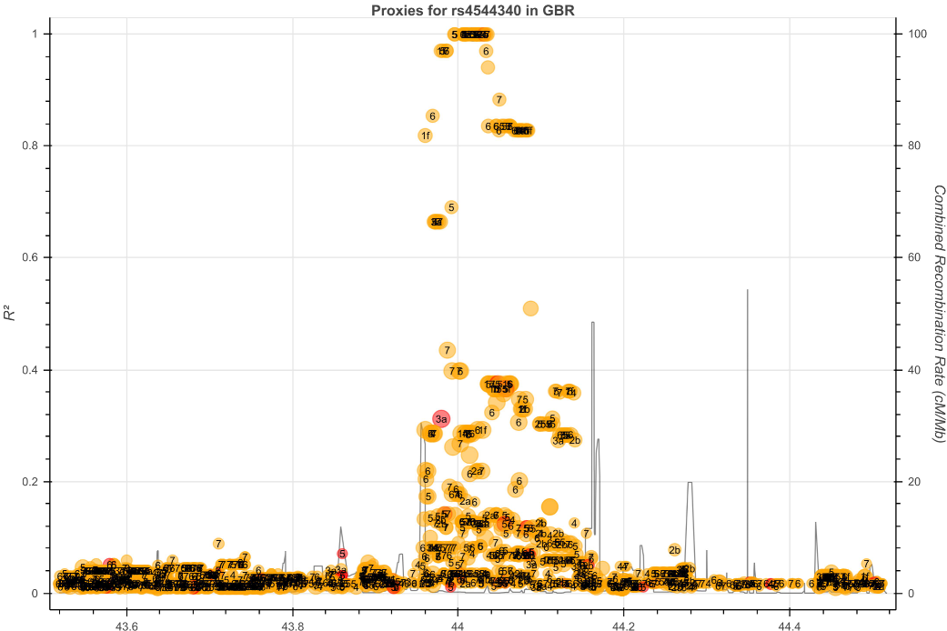

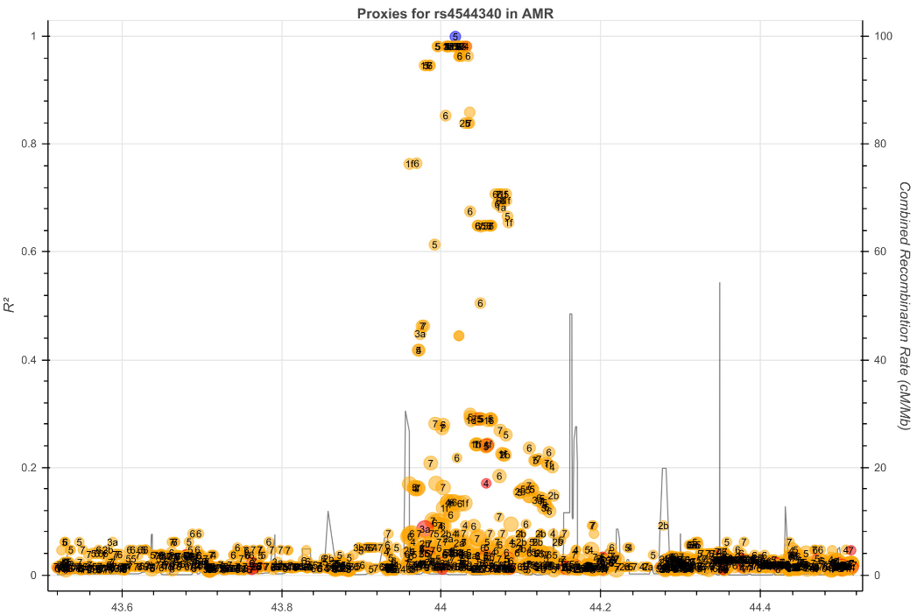

**Figure S10.1**

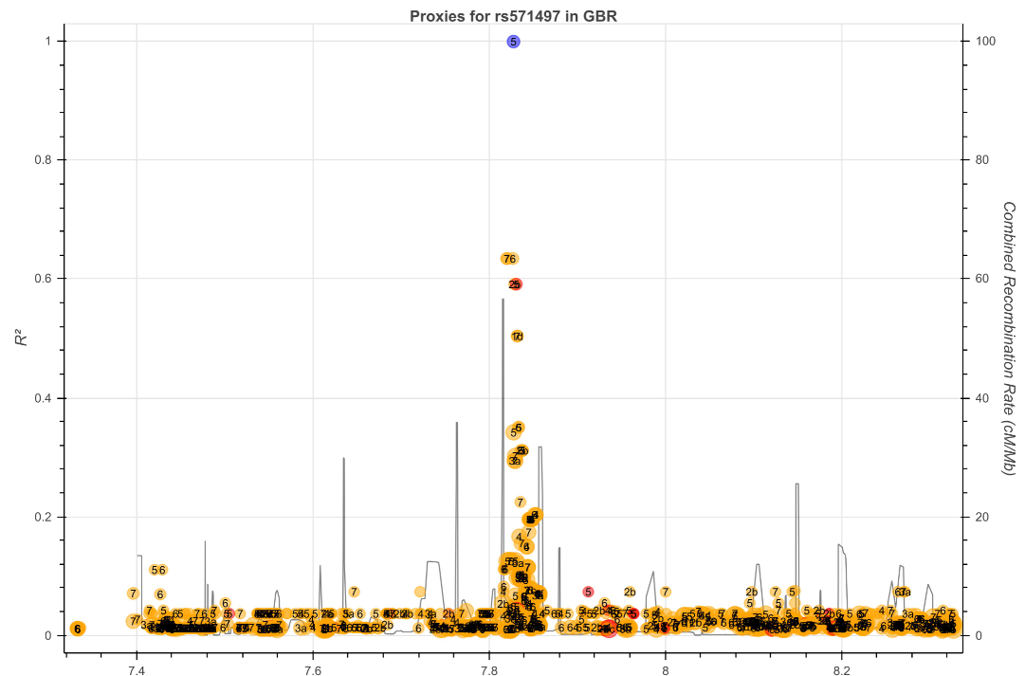

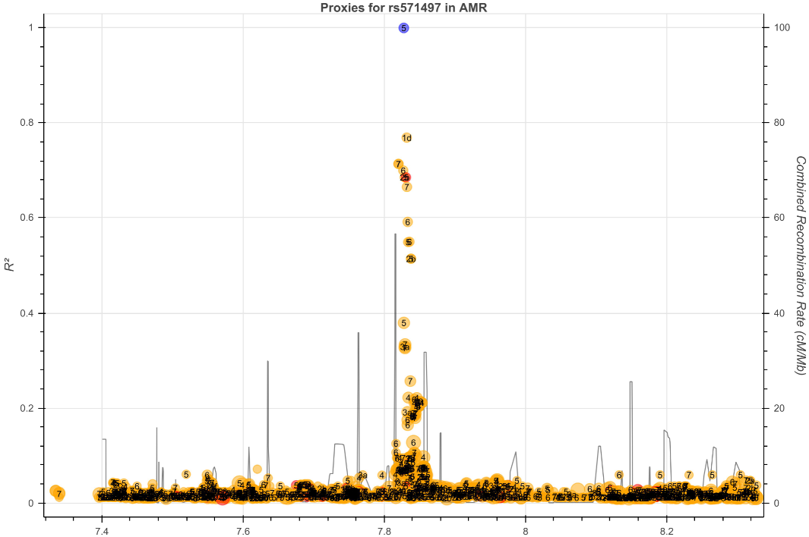

**Figure S10.2**

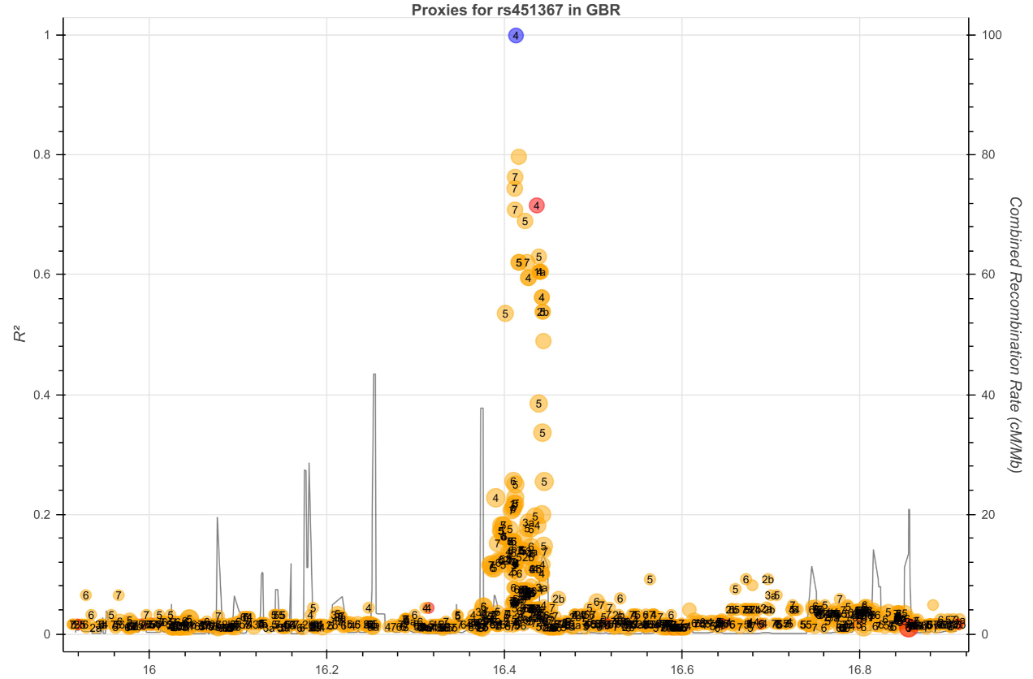

**Figure S10.3**