**Supplementary File 12**: Cross-Ancestry analysis related to UKB vs. EAS comparison. Blue=query variants; Orange= functional non-coding variants; Red=functional coding variants; 1-7=RegulomeDB score.

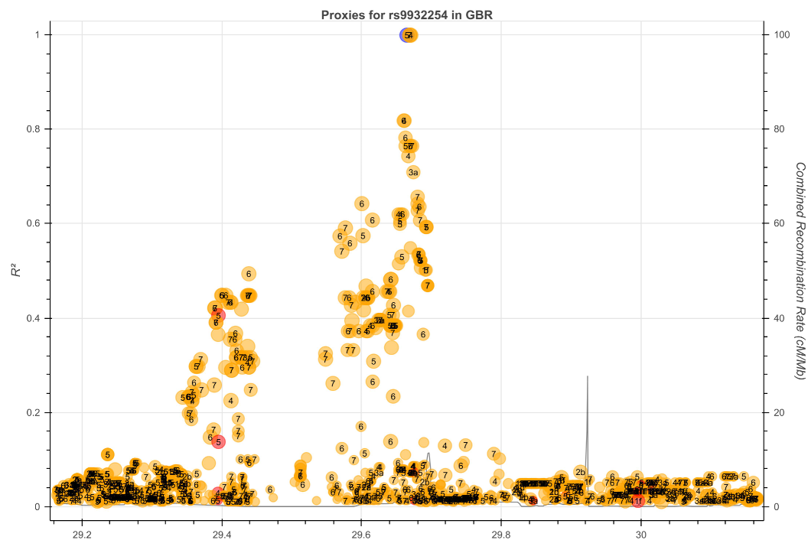

**Figure S12.1**

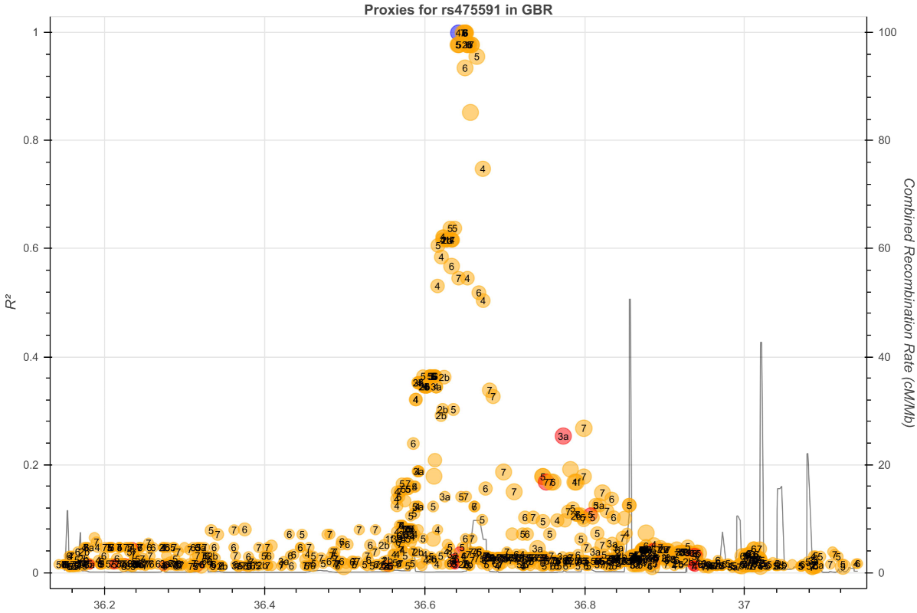

**Figure S12.2**

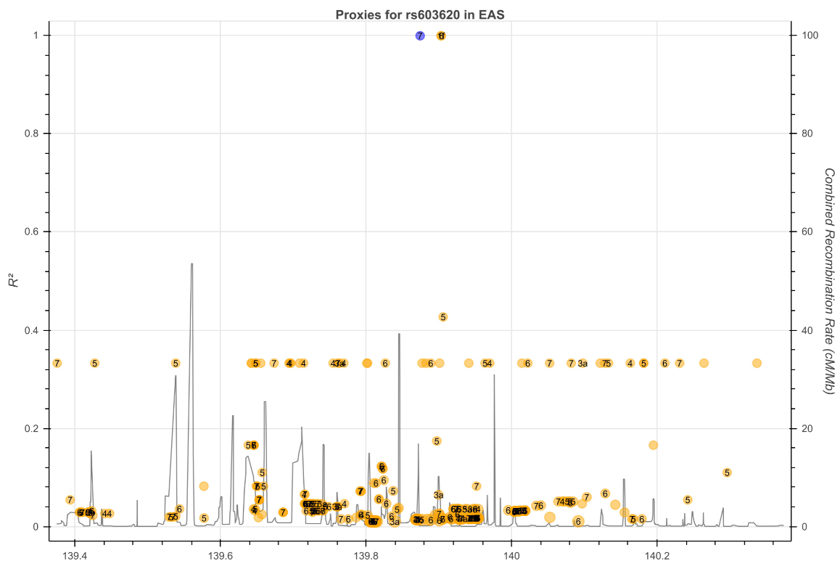

**Figure S12.3**

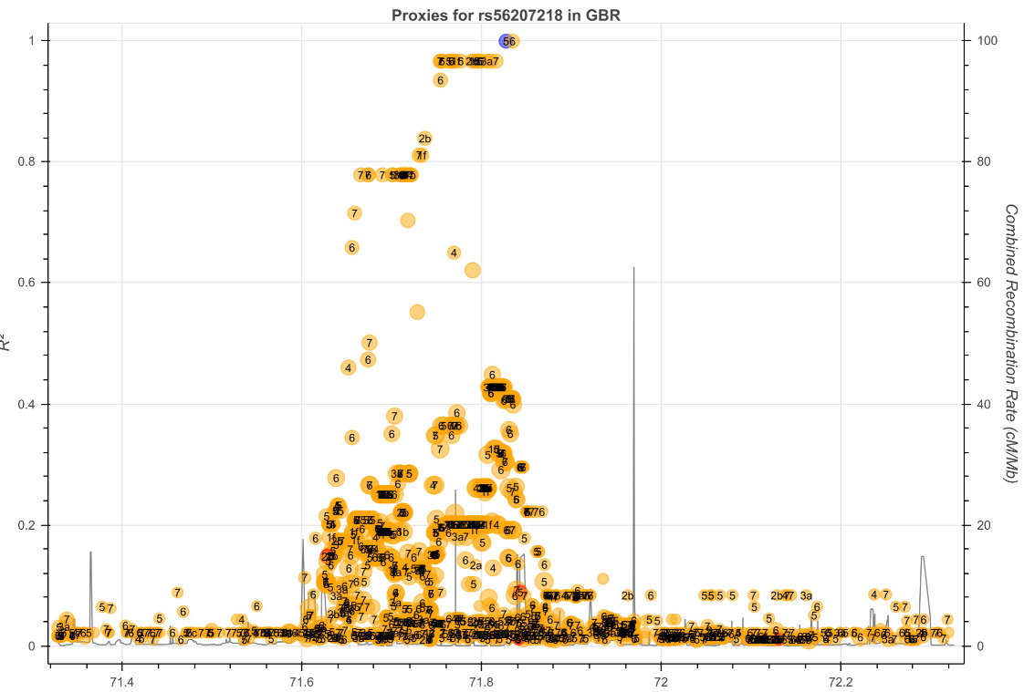

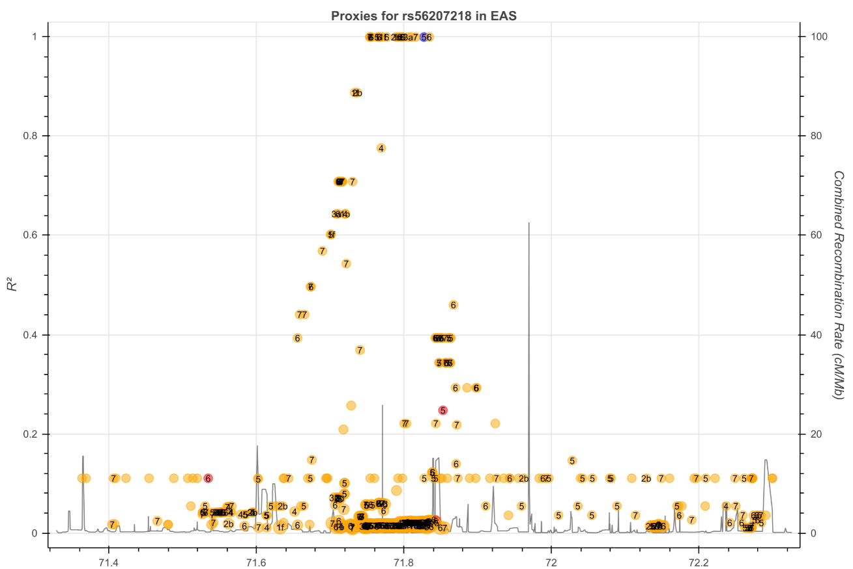

**Figure S12.4**

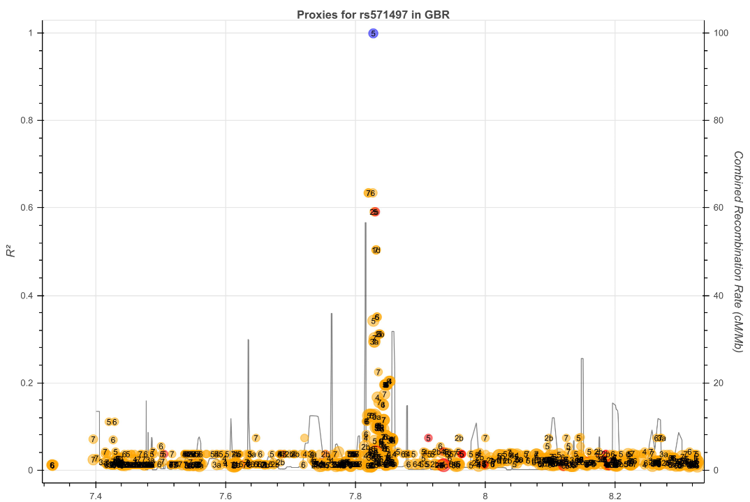

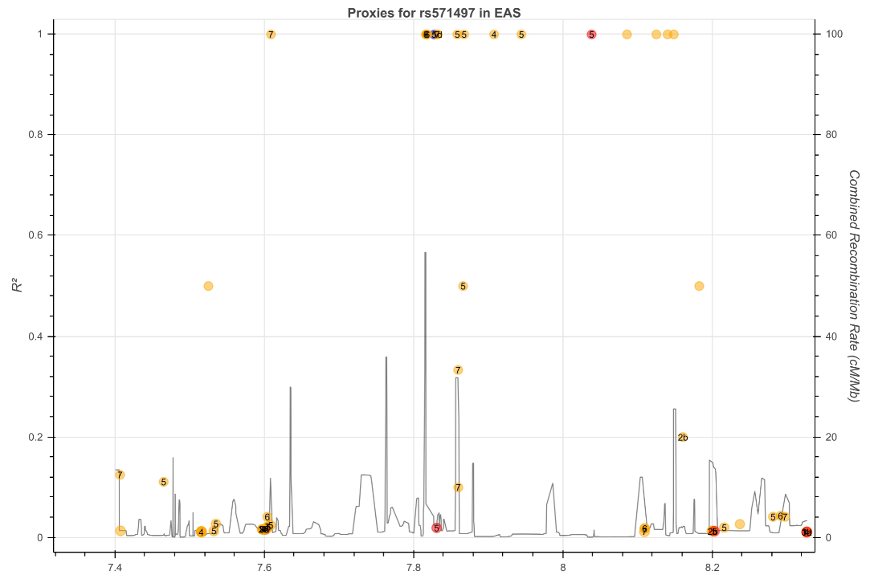

**Figure S12.5**