**Supplementary Appendix 1.**

**A.**

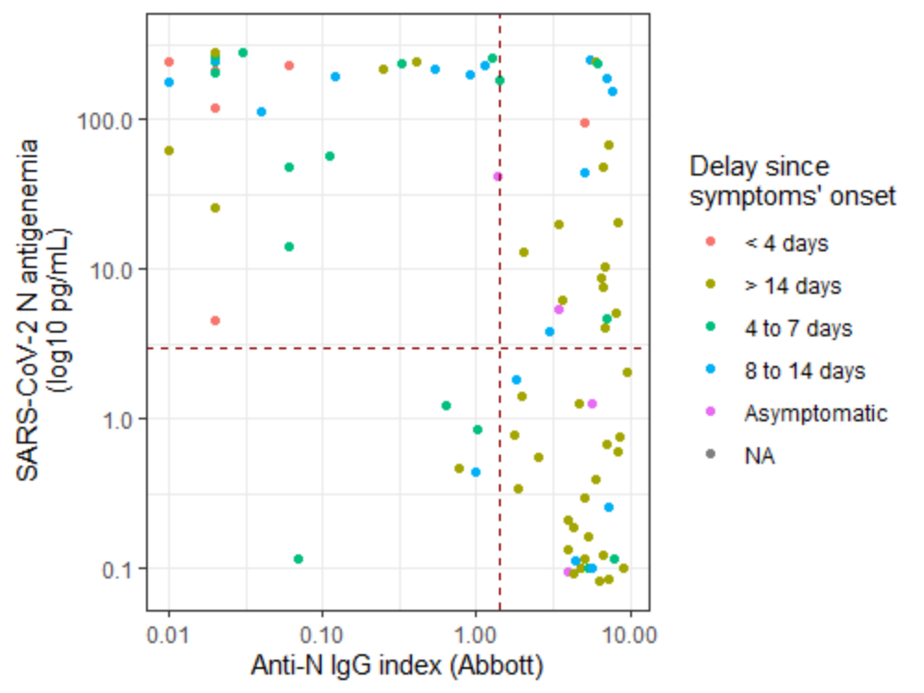

**B.**

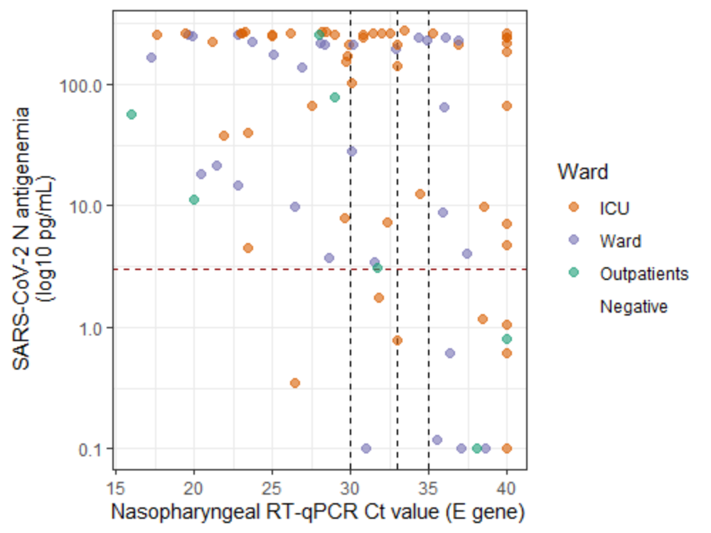

**Panel (A):** N-antigen sera levels according to anti-N IgG index (Abbot). The positivity threshold values for N-antigen (2.97 pg/mL) and anti-N IgG index (1.4) are indicated with dashed red lines.

**Panel (B):** N-antigen sera levels according to E-gene cycle threshold value of nasopharyngeal swabs collected within 24 hours. The positivity threshold value for N-antigen (2.97 pg/mL) is indicated with a dashed red line. The RT-PCR Ct values of 30, 33 and 35 are indicated with dashed black lines.