**Sup Table 1. Description of databases used**

|  |  |  |
| --- | --- | --- |
| **database Id** | **Database Name** | **Description** |
| CUIMC | Columbia University Irving Medical Center | The clinical data warehouse of NewYork-Presbyterian Hospital/Columbia University Irving Medical Center, New York, NY, based on its current and previous electronic health record systems, with data spanning over 30 years and including over 6 million patients |
| HIRA | Health Insurance Review & Assessment Service | National claim data from a single insurance service from South Korea. It contains the observational medical records (including both inpatient and outpatient) of a patient while they are qualified to get the national medical insurance. |
| HM | HM Hospitals | Hospital de Madrid (HM) Hospitals data are made available through partnership with IDIAPJGol. The HM Hospitals database covers in-patient care delivered across a network of 17 private hospitals in Spain between 1st of March and 24th of April 2020. HM Hospitals database covers more than 2300 confirmed COVID-19 cases, and all in-patient hospital care, including the data of admission, conditions, procedures and medicines dispensed in hospital, date of discharge, and date of known death or date of end of follow-up in the database. |
| Nanfang | Nanfang Hospital COVID-19 Research Database (NFHCRD) | The clinical data warehouse of The People's Hospital of HongHuï¼ŒHubeiï¼ŒChinaï¼Œbased on its current and previous electronic health record systems, with data spanning over 4 months and including over 400 patients. |
| OPTUM EHR | Optum EHR | Optum© de-identified Electronic Health Record Dataset represents Humedica’s Electronic Health Record data a medical records database for patients receiving a COVID-19 diagnosis record or lab test for SARS-CoV-2. The medical record data includes clinical information, inclusive of prescriptions as prescribed and administered, lab results, vital signs, body measurements, diagnoses, procedures, and information derived from clinical Notes using Natural Language Processing (NLP). |
| PREMIER | Premier | The Premier Healthcare Database contains complete clinical coding, hospital cost, and patient billing data from approximately 700 hospitals throughout the United States representing 20% of inpatient hospital stays. Premier collects data from participating hospitals in its health care alliance. The Premier health care alliance was formed for hospitals to share knowledge, improve patient safety, and reduce risks. Participation in the Premier health care alliance is voluntary. Although the database excludes federally funded hospitals (e.g., Veterans Affairs), the hospitals included are nationally representative based on bed size, geographic region, location (urban/rural) and teaching hospital status. The database contains a date-stamped log of all billed items by cost-accounting department including medications; laboratory, diagnostic, and therapeutic services; and primary and secondary diagnoses for each patient’s hospitalization. |
| STARR-OMOP | STARR-OMOP | STAnford medicine Research data Repository, a clinical data warehouse containing live Epic data from Stanford Health Care, the Stanford Children’s Hospital, the University Healthcare Alliance and Packard Children's Health Alliance clinics and other auxiliary data from Hospital applications such as radiology PACS. STARR platform is developed and operated by Stanford Medicine Research IT team and is made possible by Stanford School of Medicine Research Office. https://arxiv.org/abs/2003.10534 |
| TRDW | Tufts Research Data Warehouse | Electronic medical record data on approximately 1 million patients who received care beginning in 2006 at Tufts Medical Center (TMC). TMC is an academic medical center that includes Tuft Medical Center's main downtown Boston hospital for adult patients, the Floating Hospital for Children, and associated primary and specialty care clinics. TRDW contains TMC's EHR data fused with data on the same patients from TMC's CoC accredited tumor registry, its oncology EHR, and death data from the Massachusetts State Registry of Vital Statistics. EHR data streams ingested into TRDW include controlled vocabulary data on all domains except cost and select free text sources and devices. |
| VA | Department of Veterans Affairs | VA OMOP data reflects the national Department of Veterans Affairs health care system, which is the largest integrated provider of medical and mental health services in the United States. Care is provided at 170 VA Medical Centers and 1,063 outpatient sites serving more than 9 million enrolled Veterans each year. |

**Supplementary Figure 1. Standardized mean differences (SMD) of prevalence of use of adjuvant therapies before and after diagnosis of COVID.**

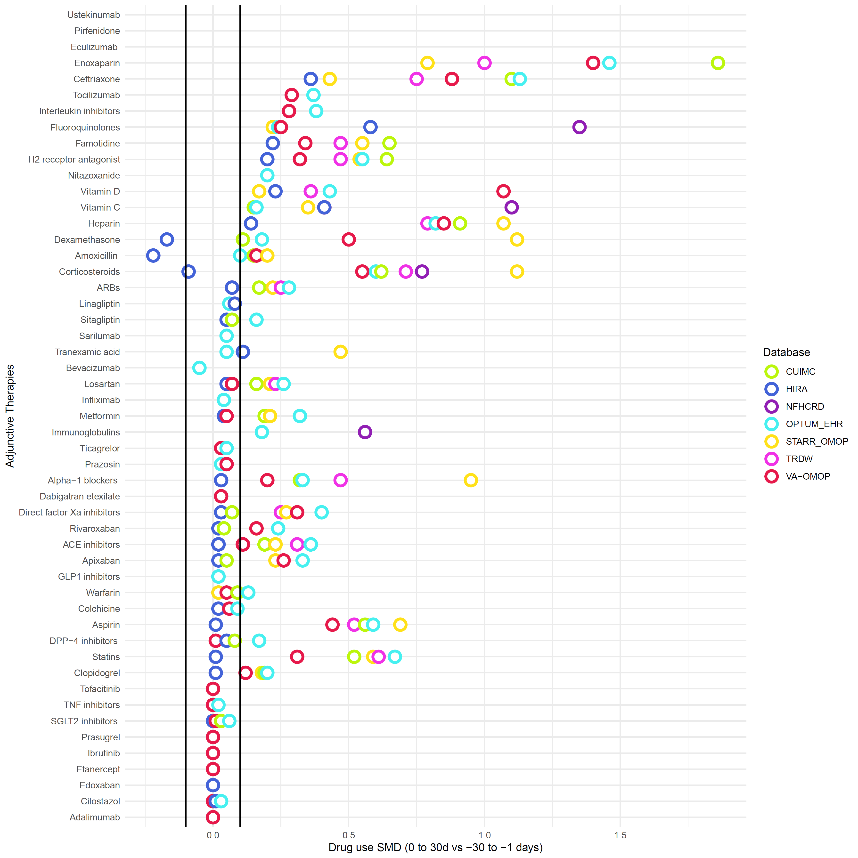

**Supplementary Figure 2. Lollipop plot showing proportion of patients receiving adjunctive therapies in hospitalized or intensive services settings.**

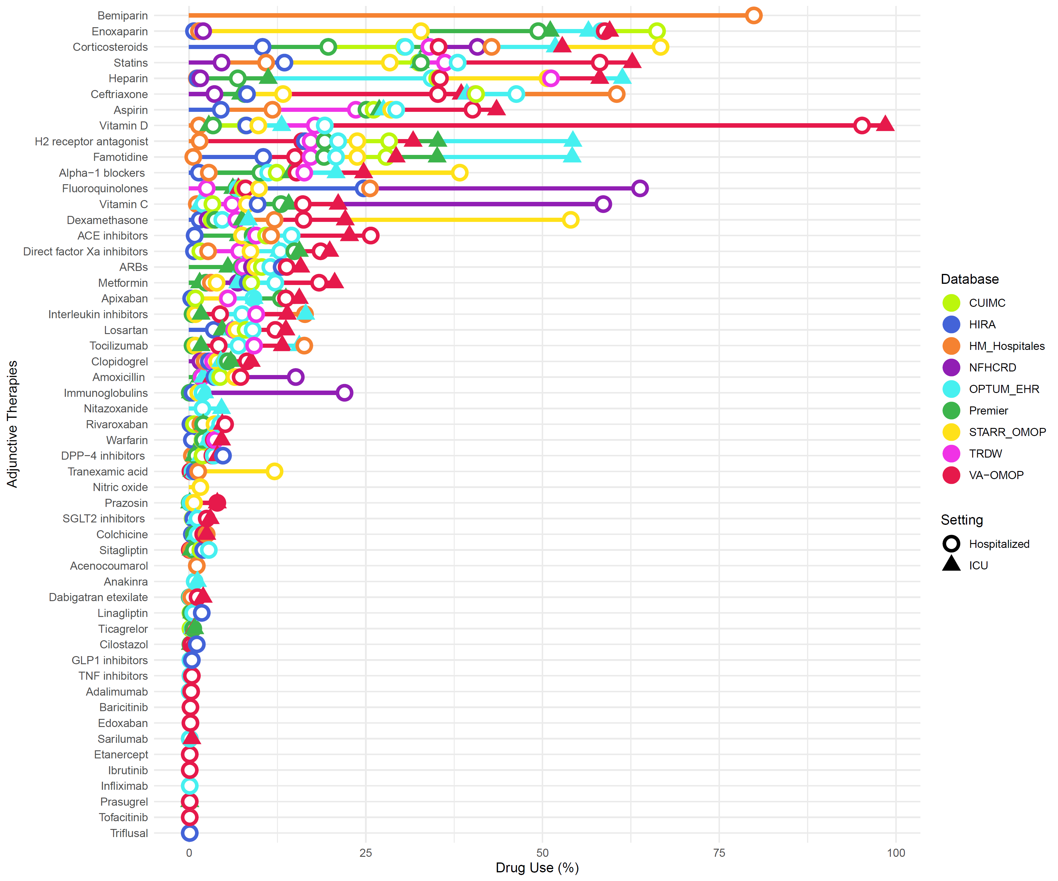

**Supplementary Figure 3. Time trends of all studied drugs in hospitalized patients Jan-June 2020**

See attached pdf (Supplementary material 2 trends.pdf)