**Survey on novel coronavirus disease (COVID-19) immunization strategies**

Clinical trials of candidate novel coronavirus disease (COVID-19) vaccines are currently underway. If and when a COVID-19 vaccine (or vaccines) becomes available in Canada, initial supplies are not expected to be sufficient to cover all Canadians right away. Therefore, certain groups will receive the vaccine earlier than others.

In order to plan for the efficient, effective, and equitable allocation, distribution, and administration of the eventual COVID-19 vaccine, the Public Health Agency of Canada (PHAC) is surveying various stakeholder groups to rank the relative importance of pandemic immunization strategies for targeted vaccination in different pandemic scenarios at the time of initial COVID-19 vaccine availability. The survey results will be used to inform decision-making by Canada’s National Advisory Committee on Immunization (NACI) 1 on recommended target groups for early COVID-19 vaccination when it may not be feasible to vaccinate all Canadians right away.

Canada’s COVID-19 pandemic response public health goals, potential pandemic immunization strategies to best achieve these goals when it may not be feasible to vaccinate all Canadians immediately, and potential target groups for early COVID-19 vaccination under each of these strategies are presented in the figure below.

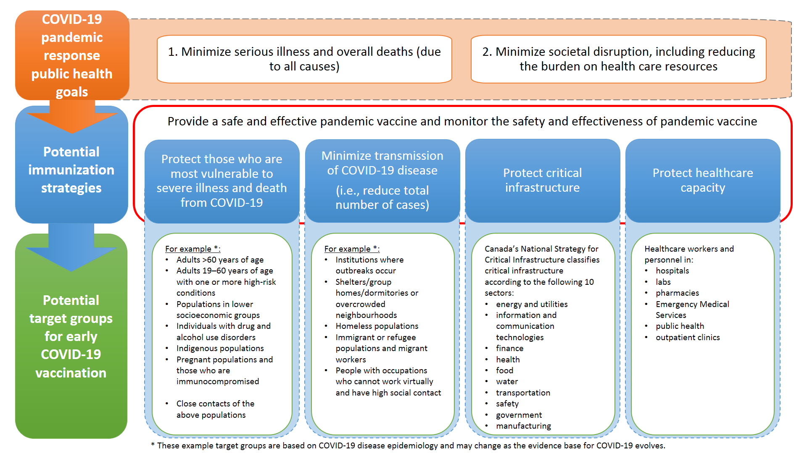

Clear pandemic immunization strategies will facilitate federal, provincial, and territorial program planning and inform federal investment and policy decisions. However, the final pandemic vaccine recommendations in Canada cannot be made until more is known about the pandemic vaccine characteristics (e.g., efficacy, safety, dosing schedule), how well the candidate vaccines work in different populations (e.g., immunocompromised, elderly), and the supply situation.

**SURVEY INSTRUCTIONS**

**This survey should take about 5 minutes to complete.** The results of this survey will be aggregated for publication, in order to document decision-making throughout Canada’s pandemic response. No individual respondent or jurisdiction will be identified based on their responses.

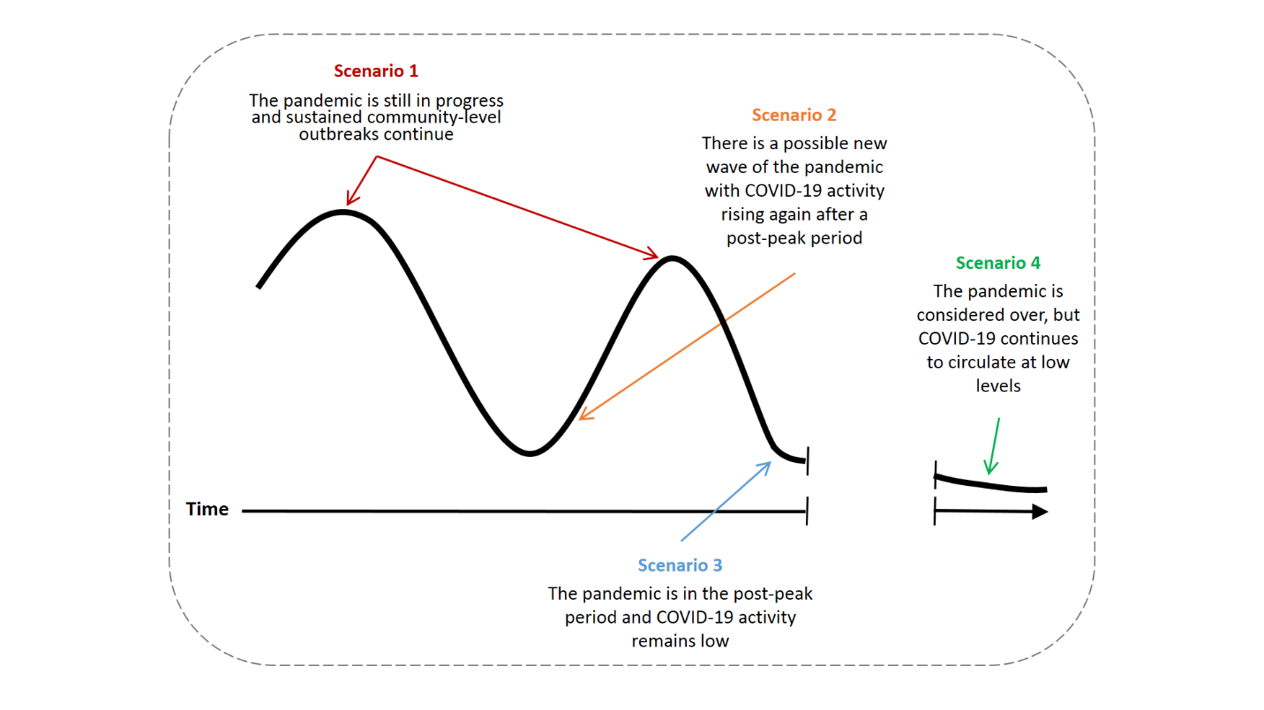**This survey asks you to rank COVID-19 pandemic immunization strategies in order of importance for each of four pandemic scenarios.** These scenarios are visually represented in the hypothetical epidemic curve below.

**For the purposes of this survey, please assume that the vaccine is safe and efficacious for all populations.**

**Please provide distinct ranks in the order of importance.** When choosing an item from the drop-down options for each scenario, please note that the numbers correspond to order of importance:

1 = most important

2 = important

3 = less important

4 = least important

5 = least important (if “other” is specified)

**Written comments are welcome.** If you feel an additional pandemic immunization strategy should be included, please specify it in the list of strategies and include it in the ranking of importance with the other strategies for all four pandemic scenarios.

**- Survey starts on next page -**

**SCENARIO 1**

**At the time of COVID-19 vaccine availability, the pandemic is still in progress and sustained community-level COVID-19 outbreaks continue.**

The COVID-19 vaccine is in limited supply. In this context, how would you rank the following COVID-19 immunization strategies in order of importance from 1 to 4 (or 5, if an additional strategy is specified), with 1 being the most important strategy?

|  |  |
| --- | --- |
| **Pandemic immunization strategy** | **Order of importance**  1 = most important  4 (or 5, if “other” is specified) = least important |
| Protect those who are most vulnerable to severe illness and death from COVID-19 | Choose an item. |
| Minimize transmission of COVID-19 disease (i.e., reduce total number of cases) | Choose an item. |
| Protect critical infrastructure | Choose an item. |
| Protect healthcare capacity | Choose an item. |
| Other (please specify): Click or tap here to enter text. | Choose an item. |

**SCENARIO 2**

**At the time of COVID-19 vaccine availability, there is a possible new wave of the pandemic with COVID-19 activity rising again after a post-peak period.**

The COVID-19 vaccine is in limited supply. In this context, how would you rank the following COVID-19 immunization strategies in order of importance from 1 to 4 (or 5, if an additional strategy is specified), with 1 being the most important strategy?

|  |  |
| --- | --- |
| **Pandemic immunization strategy** | **Order of importance**  1 = most important  4 (or 5, if “other” is specified) = least important |
| Protect those who are most vulnerable to severe illness and death from COVID-19 | Choose an item. |
| Minimize transmission of COVID-19 disease (i.e., reduce total number of cases) | Choose an item. |
| Protect critical infrastructure | Choose an item. |
| Protect healthcare capacity | Choose an item. |
| Other (please specify): Click or tap here to enter text. | Choose an item. |

**- Survey continues on next page -**

**SCENARIO 3**

**At the time of COVID-19 vaccine availability, the pandemic is in the post-peak period and COVID-19 activity remains low.**

The COVID-19 vaccine is in limited supply. In this context, how would you rank the following COVID-19 immunization strategies in order of importance from 1 to 4 (or 5, if an additional strategy is specified), with 1 being the most important strategy?

|  |  |
| --- | --- |
| **Pandemic immunization strategy** | **Order of importance**  1 = most important  4 (or 5, if “other” is specified) = least important |
| Protect those who are most vulnerable to severe illness and death from COVID-19 | Choose an item. |
| Minimize transmission of COVID-19 disease (i.e., reduce total number of cases) | Choose an item. |
| Protect critical infrastructure | Choose an item. |
| Protect healthcare capacity | Choose an item. |
| Other (please specify): Click or tap here to enter text. | Choose an item. |

**SCENARIO 4-A**

**At the time of COVID-19 vaccine availability, the pandemic is considered over, but COVID-19 continues to circulate at low levels. There is evidence that the vaccine (or previous infection) provides long-term protection against COVID-19, but a routine vaccination program may be required for new cohorts that are immunologically naïve.**

The COVID-19 vaccine is in limited supply. In this context, how would you rank the following COVID-19 immunization strategies in order of importance from 1 to 4 (or 5, if an additional strategy is specified), with 1 being the most important strategy?

|  |  |
| --- | --- |
| **Pandemic immunization strategy** | **Order of importance**  1 = most important  4 (or 5, if “other” is specified) = least important |
| Protect those who are most vulnerable to severe illness and death from COVID-19 | Choose an item. |
| Minimize transmission of COVID-19 disease (i.e., reduce total number of cases) | Choose an item. |
| Protect critical infrastructure | Choose an item. |
| Protect healthcare capacity | Choose an item. |
| Other (please specify): Click or tap here to enter text. | Choose an item. |

**- Survey continues on next page -**

**SCENARIO 4-B**

**At the time of COVID-19 vaccine availability, the pandemic is considered over, but COVID-19 continues to circulate at low levels.** **There is evidence that the vaccine (or previous infection) does not provide long-term protection against COVID-19 and a routine vaccination program will be required for much of the population.**

The COVID-19 vaccine is in limited supply and immunity against COVID-19 wanes over time, necessitating re-vaccination to maintain protection. In this context, how would you rank the following COVID-19 immunization strategies in order of importance from 1 to 4 (or 5, if an additional strategy is specified), with 1 being the most important strategy?

|  |  |
| --- | --- |
| **Pandemic immunization strategy** | **Order of importance**  1 = most important  4 (or 5, if “other” is specified) = least important |
| Protect those who are most vulnerable to severe illness and death from COVID-19 | Choose an item. |
| Minimize transmission of COVID-19 disease (i.e., reduce total number of cases) | Choose an item. |
| Protect critical infrastructure | Choose an item. |
| Protect healthcare capacity | Choose an item. |
| Other (please specify): Click or tap here to enter text. | Choose an item. |

**Thank you for participating in this survey.**

**Please return the completed survey to:** phac.naci-ccni.aspc@canada.ca